1

**4-4 UI Design**

Harvey Corey

Southern New Hampshire University

CS-360-18509-M01 Mobile Architect & Programming 2024 C-6 (Oct - Dec)

Professor Alex Benavente

Dec 7, 2024

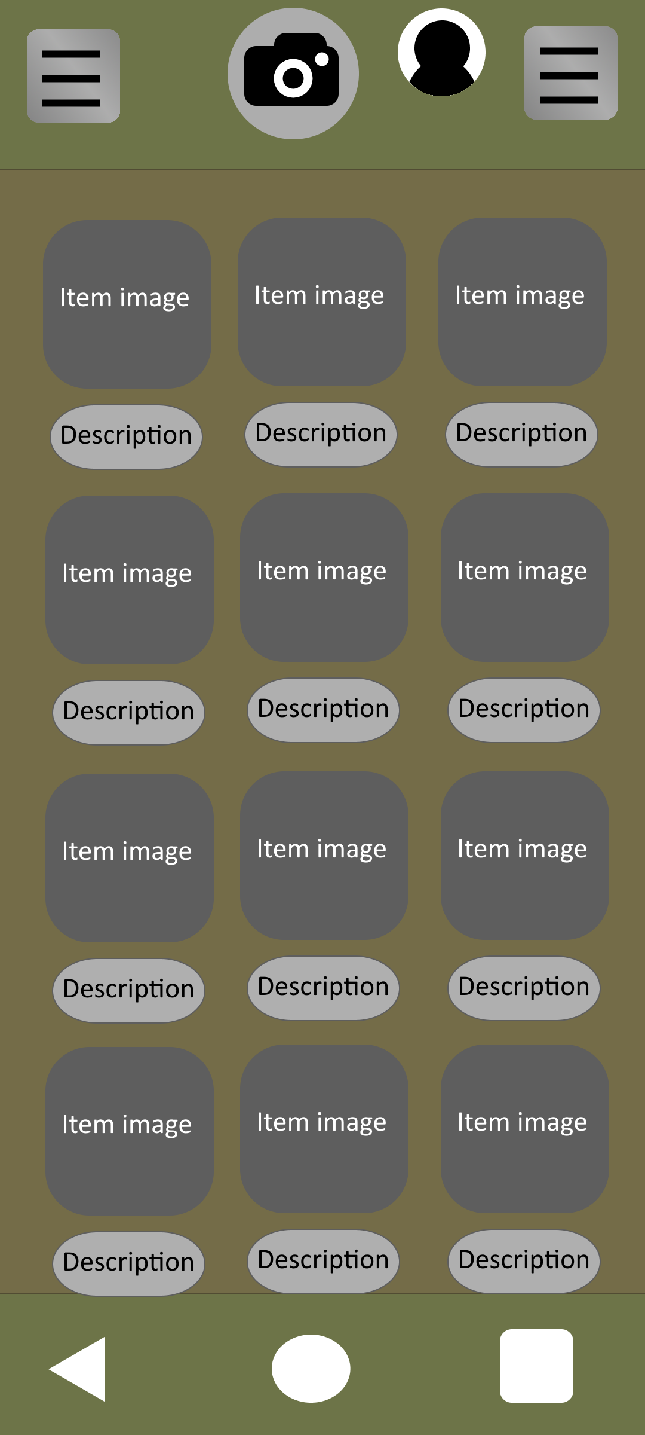

This is the UI design that I have decided to be a rough draft of the main inventory menu.

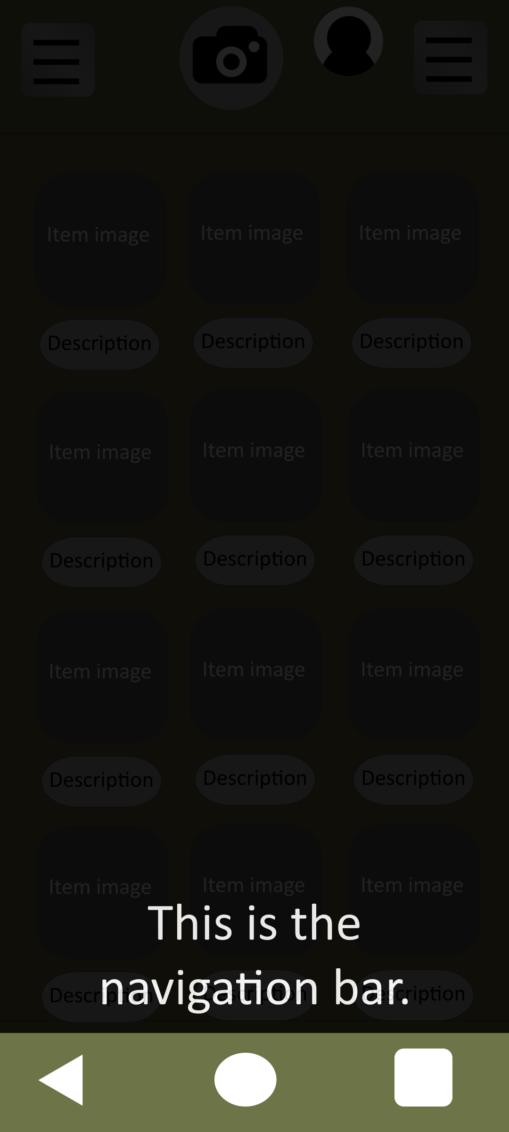

The navigation bar will allow users to navigate around their phone or on pages of the app quickly.

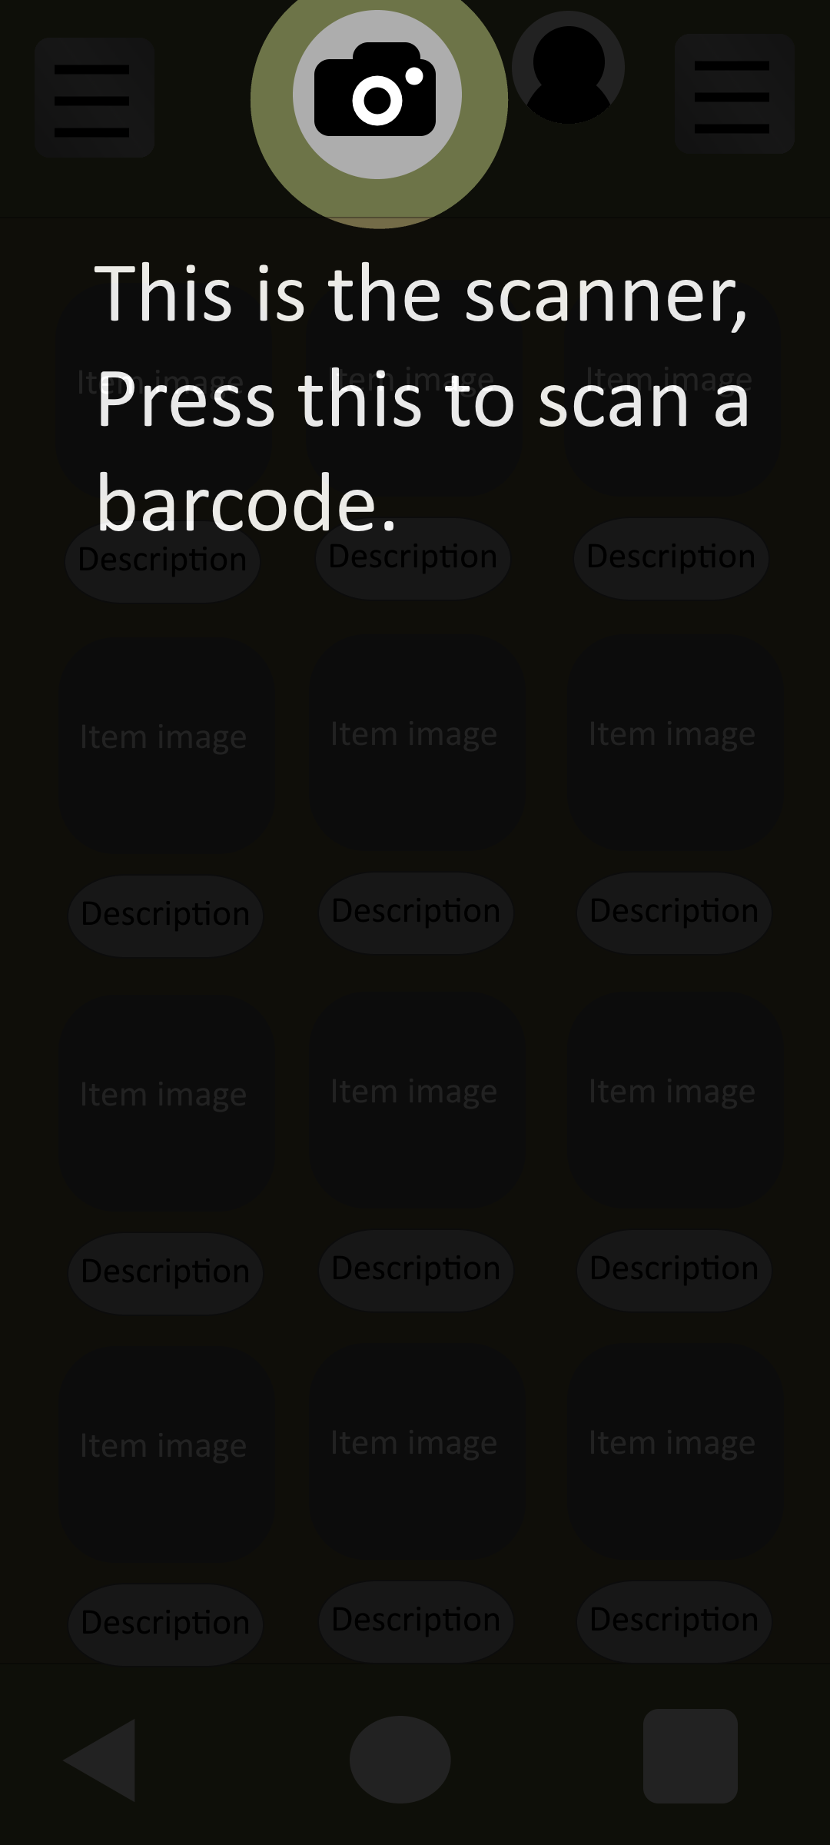

The scanner allows users to quickly scan a barcode on a box to retrieve and modify all related information in regard to that item.

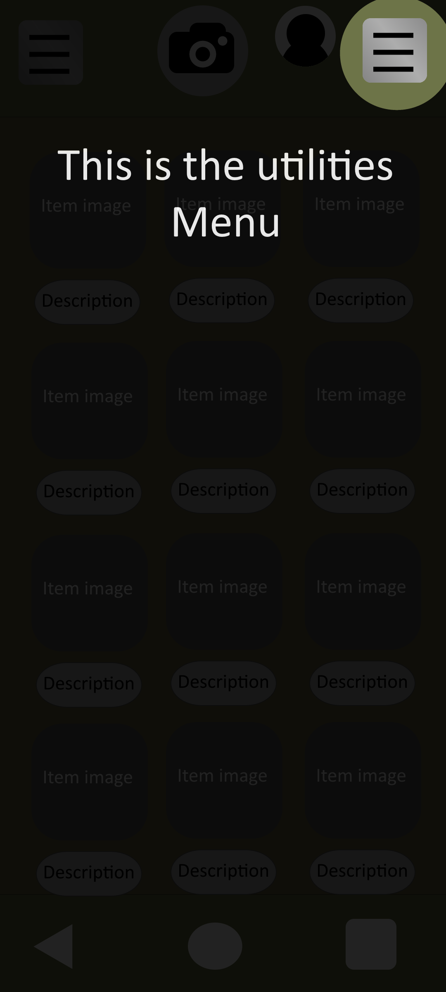

The Utilities menu allows for user to change filters, sorting settings, black/white lists, preferences and anything else that is decided upon in the future.

This is located on the right side of the screen for quick access, since most users are likely right handed. The location can be changed in the settings menu.

This is where auditor accounts and IT accounts have account specific tools that relate to the specific requirements of each job. These options can only be seen by accounts that have access.

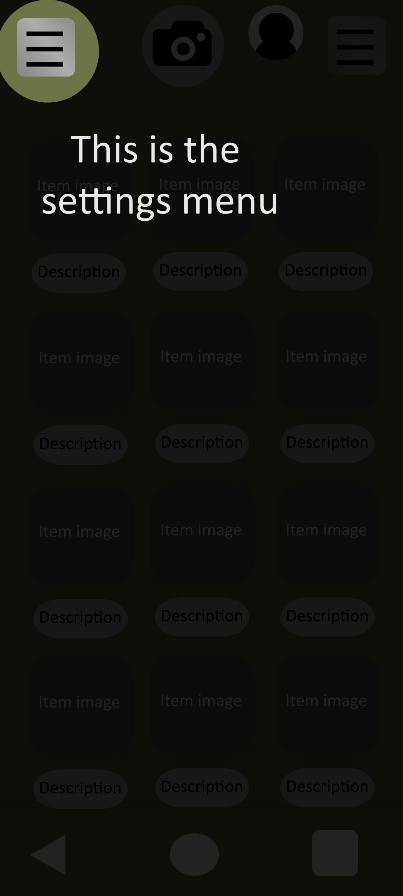

The settings menu lets you change UI settings for accessibility and more. Settings like color blind modes, text to speech, visuals, and how many items are on the page.

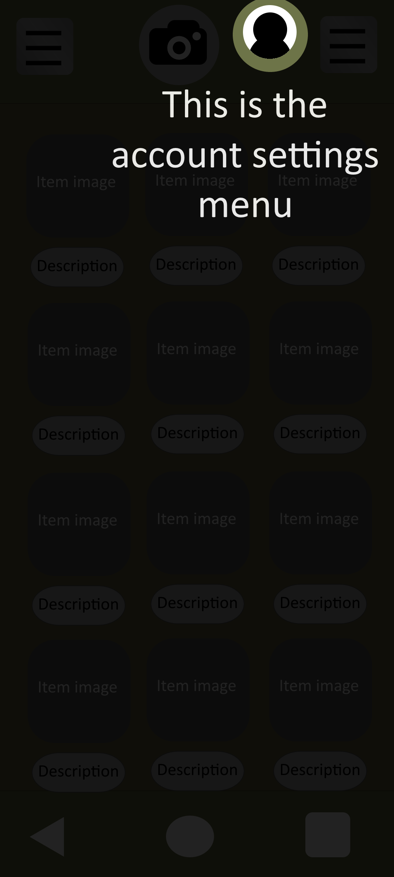

This is the user settings button. This allows the user to change information in regard to their account, like profile picture, contact information and more.